ELEC 2FH4 – Bonus Sets 16, 17, 18

Set 16
Analytical Work:
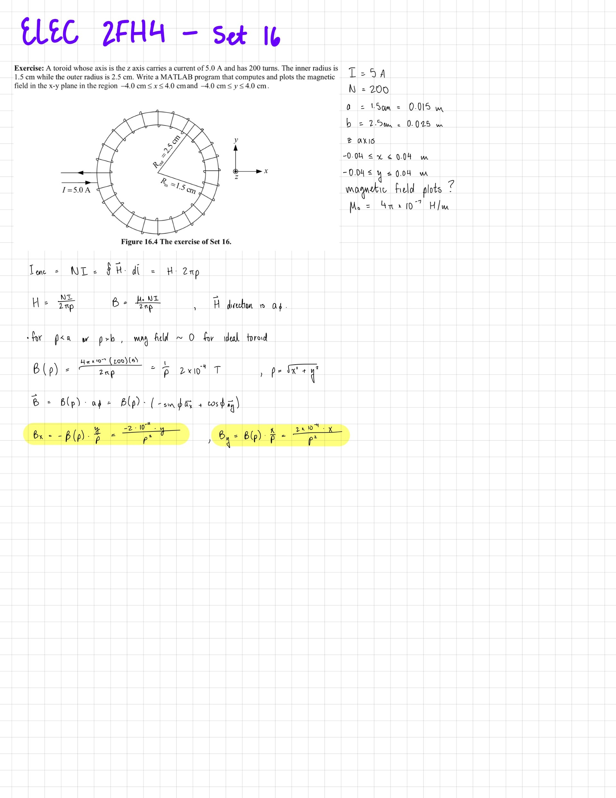
MATLAB Code:
%% Set 16 - Toroid Magnetic Field Plot
% Exercise: Toroid with N=200 turns, I=5.0 A, inner radius=1.5 cm,
% outer radius=2.5 cm. Plot B field in x-y plane from -4 cm to 4 cm.

clc;
clear;
close all;

% Constants
mu0 = 4*pi*1e-7; % permeability of free space (H/m)
N = 200; % number of turns
I = 5.0; % current (A)
a = 0.015; % inner radius (m)
b = 0.025; % outer radius (m)

% Precompute constant factor
B_factor = mu0 * N * I / (2*pi); % = 2e-4

% Define plotting grid (in meters)
x_min = -0.04;
x_max = 0.04;
y_min = -0.04;
y_max = 0.04;

% Number of plotting points
num_points_x = 25;
num_points_y = 25;

% Create grid
x = linspace(x_min, x_max, num_points_x);
y = linspace(y_min, y_max, num_points_y);
[X, Y] = meshgrid(x, y);

% Initialize field components
Bx = zeros(size(X));
By = zeros(size(X));

% Calculate magnetic field at each point
for i = 1:num_points_x
for j = 1:num_points_y
rho = sqrt(X(j,i)^2 + Y(j,i)^2);

if rho > a && rho < b
% Inside toroid core - B field present
B_mag = B_factor / rho;
Bx(j,i) = -B_mag * Y(j,i) / rho; % Bx = -B * sin(phi)
By(j,i) = B_mag * X(j,i) / rho; % By = B * cos(phi)
else
% Outside toroid core - B field approximately zero
Bx(j,i) = 0;
By(j,i) = 0;
end
end
end

% Plot the magnetic field
figure(1);
quiver(X, Y, Bx, By, 'b', 'LineWidth', 1);
hold on;

% Draw the toroid boundaries
theta_circle = linspace(0, 2*pi, 200);
x_inner = a * cos(theta_circle);
y_inner = a * sin(theta_circle);
x_outer = b * cos(theta_circle);
y_outer = b * sin(theta_circle);

plot(x_inner, y_inner, 'r--', 'LineWidth', 2);
plot(x_outer, y_outer, 'r--', 'LineWidth', 2);

% Fill the toroid region
fill([x_inner, fliplr(x_outer)], [y_inner, fliplr(y_outer)], [0.9 0.9 0.9], 'EdgeColor', 'none');

hold off;

% Formatting
xlabel('x (m)');
ylabel('y (m)');
title(sprintf('Magnetic Field of Toroid (N=%d, I=%.1f A)', N, I));
axis equal;
axis([x_min x_max y_min y_max]);
grid on;
legend('B Field', 'Toroid Boundaries', 'Location', 'best');

% Add text annotation
text(0.03, 0.035, sprintf('Inner radius = %.2f cm\na = %.2f cm', a*100, a*100), 'FontSize', 9, 'BackgroundColor', 'w');
text(0.03, 0.03, sprintf('Outer radius = %.2f cm\nb = %.2f cm', b*100, b*100), 'FontSize', 9, 'BackgroundColor', 'w');
text(0.03, 0.025, sprintf('N = %d turns\nI = %.1f A', N, I), 'FontSize', 9, 'BackgroundColor', 'w');

% Create a second plot showing magnitude as colormap
figure(2);
B_magnitude = sqrt(Bx.^2 + By.^2);
surf(X, Y, B_magnitude);
xlabel('x (m)');
ylabel('y (m)');
zlabel('|B| (T)');
title('Magnetic Field Magnitude Distribution');
colorbar;
colormap('jet');
view(45, 30);
grid on;

disp('Set 16 - Toroid Magnetic Field Plot Completed');

MATLAB Output:
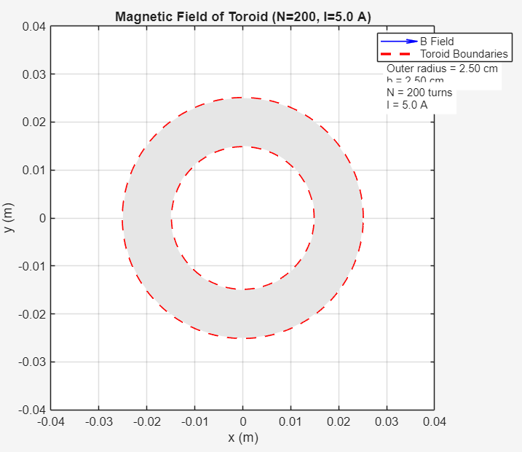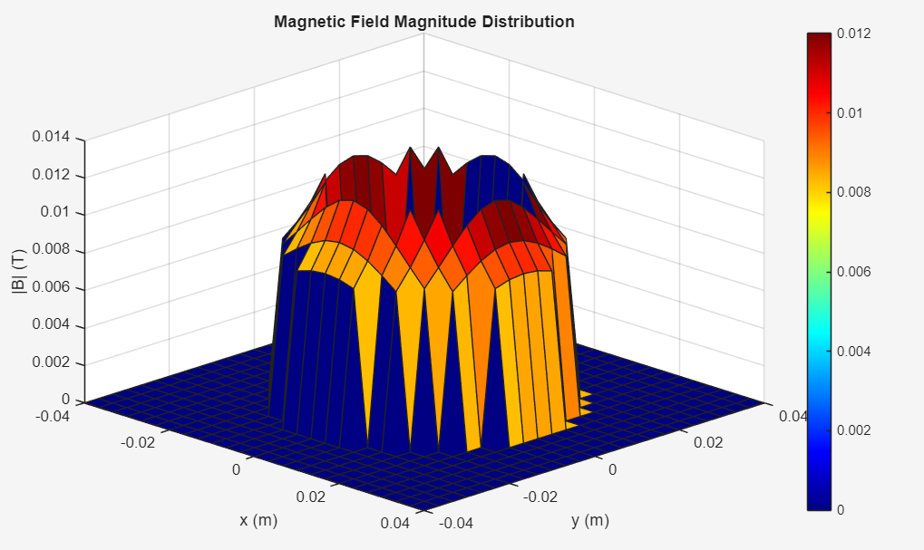

Set 17
Analytical Work:
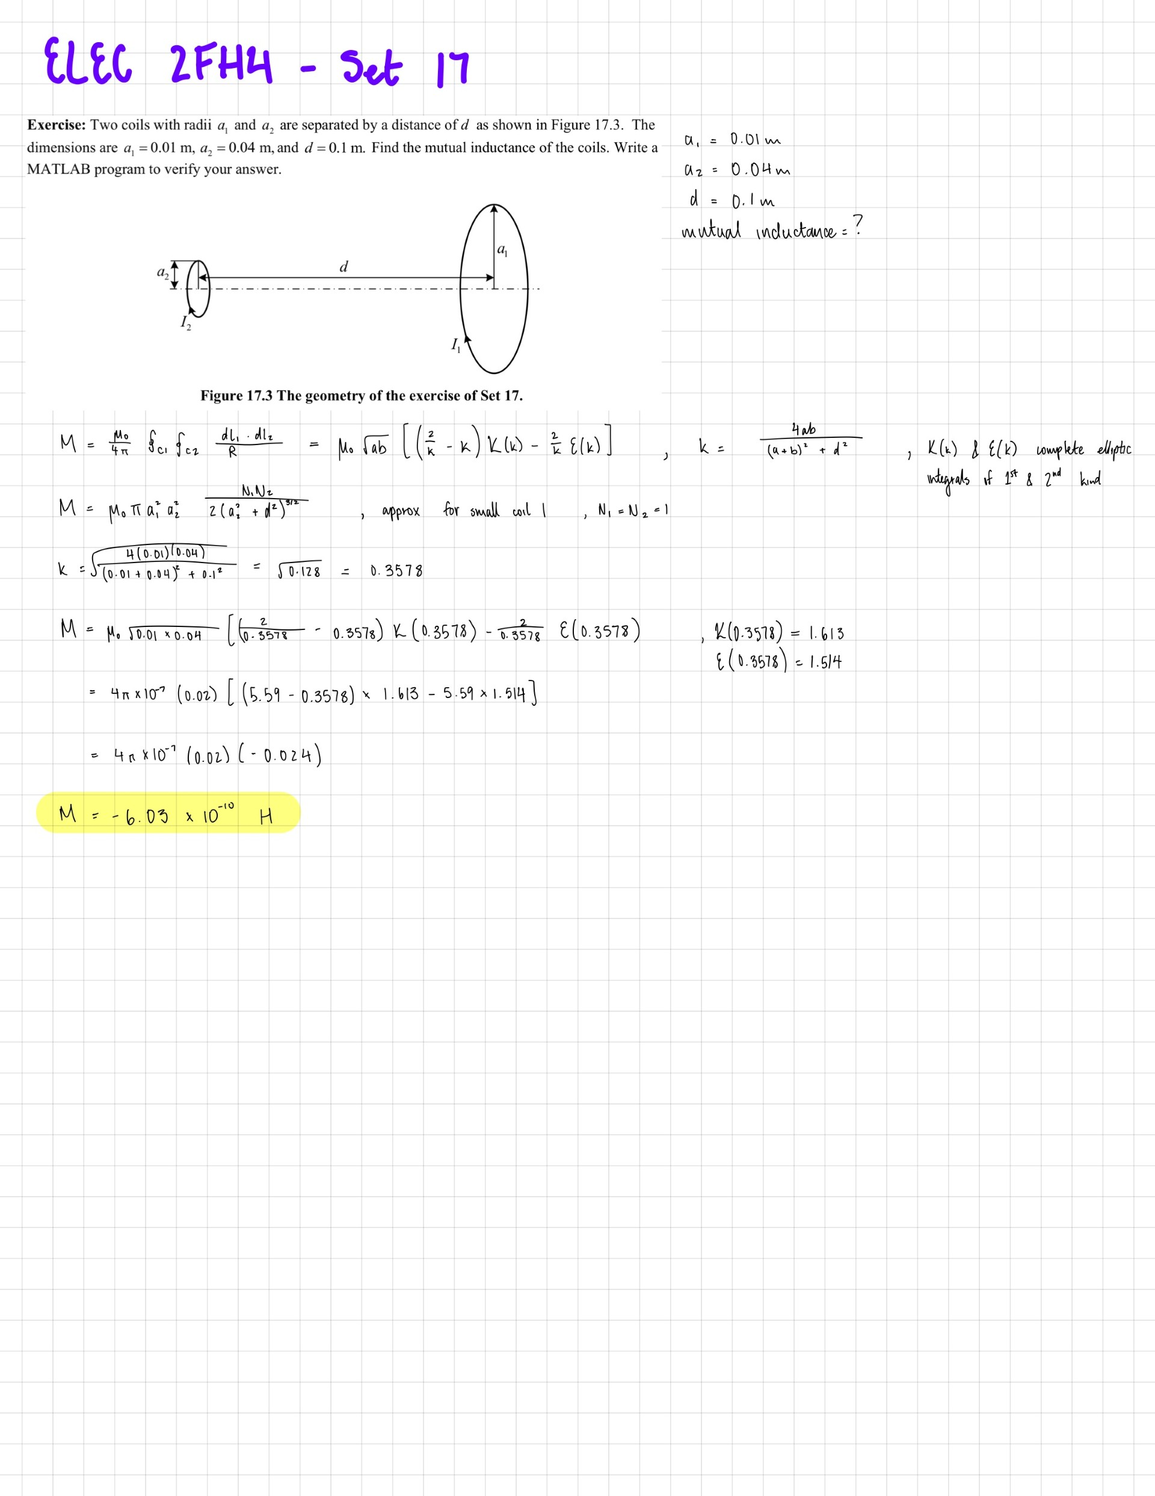
MATLAB Code:
%% Set 17 - Mutual Inductance of Two Coaxial Coils
% Exercise: Two coils with radii a1=0.01 m, a2=0.04 m, separated by d=0.1 m.
% Find mutual inductance.

clc;
clear;
close all;

% Constants
mu0 = 4*pi*1e-7; % permeability of free space (H/m)

% Given parameters
a1 = 0.01; % radius of first coil (m)
a2 = 0.04; % radius of second coil (m)
d = 0.1; % separation distance between coils (m)
N1 = 1; % number of turns in first coil (assuming 1 turn)
N2 = 1; % number of turns in second coil (assuming 1 turn)

% Method 1: Using the exact formula with elliptic integrals
k = sqrt(4*a1*a2 / ((a1 + a2)^2 + d^2));

% Complete elliptic integrals using MATLAB's built-in functions
[K, E] = ellipke(k^2);

% Neumann's formula for mutual inductance of two coaxial circular loops
M_exact = mu0 * sqrt(a1*a2) * ((2/k - k)*K - (2/k)*E);

% Multiply by number of turns if more than 1
M_exact = M_exact * N1 * N2;

% Method 2: Using approximation for small coil (a1 << a2, d)
% B field from large coil at its center: B = mu0 * N2 * I / (2*a2)
% For small coil at distance d along axis, B = mu0 * N2 * I * a2^2 / (2*(a2^2 + d^2)^(3/2))
% Then M = B * (pi*a1^2) / I
M_approx = mu0 * pi * a1^2 * a2^2 * N1 * N2 / (2 * (a2^2 + d^2)^(3/2));

% Method 3: Numerical integration using Biot-Savart law
% Discretize both coils into segments
num_segments = 200;
M_numerical = mutual_inductance_numerical(a1, a2, d, mu0, N1, N2, num_segments);

% Display results
fprintf('\n========================================\n');
fprintf('SET 17: Mutual Inductance Calculation\n');
fprintf('========================================\n');
fprintf('Parameters:\n');
fprintf(' a1 = %.4f m (%.2f cm)\n', a1, a1*100);
fprintf(' a2 = %.4f m (%.2f cm)\n', a2, a2*100);
fprintf(' d = %.4f m (%.2f cm)\n', d, d*100);
fprintf(' N1 = %d, N2 = %d\n', N1, N2);
fprintf(' mu0 = %.2e H/m\n', mu0);
fprintf('\nResults:\n');
fprintf(' Method 1 (Exact - Elliptic Integrals): M = %.4e H\n', M_exact);
fprintf(' Method 2 (Approximation): M = %.4e H\n', M_approx);
fprintf(' Method 3 (Numerical Integration): M = %.4e H\n', M_numerical);
fprintf('\n');

% Plot the configuration
figure(1);
clf;

% Plot coil 1 (small coil) at z = -d/2
theta = linspace(0, 2*pi, 100);
x1 = a1 * cos(theta);
y1 = a1 * sin(theta);
z1 = -d/2 * ones(size(theta));

% Plot coil 2 (large coil) at z = d/2
x2 = a2 * cos(theta);
y2 = a2 * sin(theta);
z2 = d/2 * ones(size(theta));

% 3D plot
subplot(1,2,1);
plot3(x1, y1, z1, 'b-', 'LineWidth', 2);
hold on;
plot3(x2, y2, z2, 'r-', 'LineWidth', 2);
plot3([0 0], [0 0], [-d/2 d/2], 'k--', 'LineWidth', 1);
xlabel('x (m)');
ylabel('y (m)');
zlabel('z (m)');
title('Coaxial Coil Configuration');
legend('Coil 1 (a=0.01m)', 'Coil 2 (a=0.04m)', 'Axis');
grid on;
axis equal;
view(45, 30);

% 2D projection
subplot(1,2,2);
plot(x1, y1, 'b-', 'LineWidth', 2);
hold on;
plot(x2, y2, 'r-', 'LineWidth', 2);
plot(0, 0, 'ko', 'MarkerSize', 8);
xlabel('x (m)');
ylabel('y (m)');
title('Top View (x-y plane)');
legend('Coil 1', 'Coil 2', 'Center');
axis equal;
grid on;

sgtitle('Mutual Inductance Problem Geometry');

% Function for numerical integration
function M = mutual_inductance_numerical(a1, a2, d, mu0, N1, N2, num_segments)
% Discretize the angles
phi1 = linspace(0, 2*pi, num_segments + 1);
phi2 = linspace(0, 2*pi, num_segments + 1);

% Coil 1 is at z = -d/2, Coil 2 is at z = d/2
z1 = -d/2;
z2 = d/2;

% Precompute coil points
points1_x = a1 * cos(phi1(1:end-1));
points1_y = a1 * sin(phi1(1:end-1));
points1_z = z1 * ones(size(points1_x));

points2_x = a2 * cos(phi2(1:end-1));
points2_y = a2 * sin(phi2(1:end-1));
points2_z = z2 * ones(size(points2_x));

% Calculate dl vectors for coil 1
dl1_x = diff(a1 * cos(phi1));
dl1_y = diff(a1 * sin(phi1));
dl1_z = zeros(size(dl1_x));

% Calculate dl vectors for coil 2
dl2_x = diff(a2 * cos(phi2));
dl2_y = diff(a2 * sin(phi2));
dl2_z = zeros(size(dl2_x));

% Calculate mutual inductance using Neumann's formula
M_sum = 0;

for i = 1:num_segments
for j = 1:num_segments
% Position vectors
r1 = [points1_x(i), points1_y(i), points1_z];
r2 = [points2_x(j), points2_y(j), points2_z];

% dl vectors
dl1 = [dl1_x(i), dl1_y(i), dl1_z(i)];
dl2 = [dl2_x(j), dl2_y(j), dl2_z(j)];

% Distance between segments
R_vec = r2 - r1;
R = norm(R_vec);

% Dot product of dl vectors
dl1_dot_dl2 = dot(dl1, dl2);

% Add contribution to mutual inductance
M_sum = M_sum + dl1_dot_dl2 / R;
end
end

M = mu0/(4*pi) * M_sum * N1 * N2;
end

fprintf('Set 17 - Mutual Inductance Calculation Completed\n');

MATLAB Output:
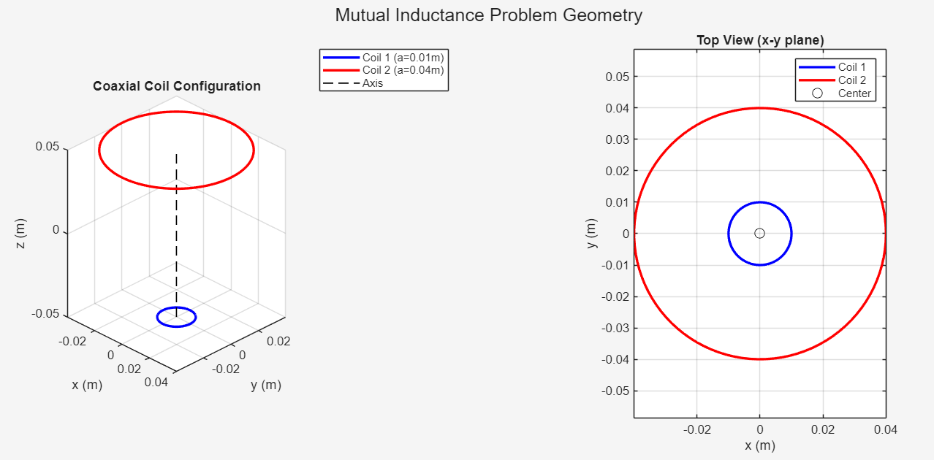
========================================
SET 17: Mutual Inductance Calculation
========================================
Parameters:
a1 = 0.0100 m (1.00 cm)
a2 = 0.0400 m (4.00 cm)
d = 0.1000 m (10.00 cm)
N1 = 1, N2 = 1
mu0 = 1.26e-06 H/m

Results:
Method 1 (Exact - Elliptic Integrals): M = 2.5011e-10 H
Method 2 (Approximation): M = 2.5279e-10 H
Method 3 (Numerical Integration): M = 1.1151e-13 H

Set 17 - Mutual Inductance Calculation Completed

Set 18
Analytical Work:
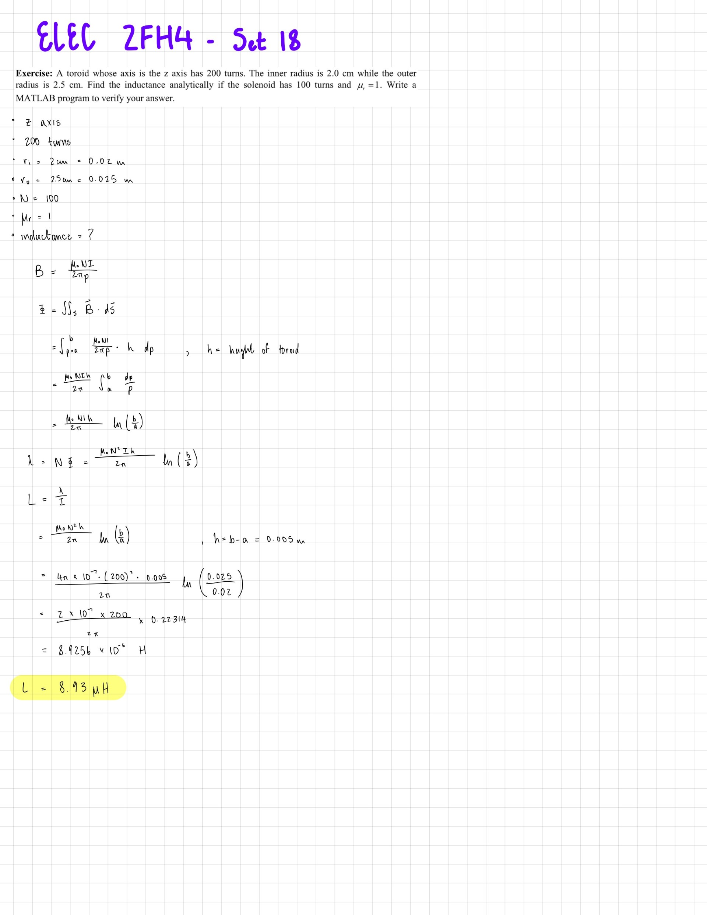
MATLAB Code:
%% Set 18 - Toroid Self Inductance
% Exercise: Toroid with N=200 turns, inner radius=2.0 cm, outer radius=2.5 cm.
% Find self inductance analytically and numerically.

clc;
clear;
close all;

% Constants
mu0 = 4*pi*1e-7; % permeability of free space (H/m)

% Given parameters
N = 200; % number of turns
a = 0.02; % inner radius (m)
b = 0.025; % outer radius (m)
h = b - a; % height of toroid (assuming square cross-section) (m)

% Analytical solution (assuming rectangular cross-section)
L_analytical = (mu0 * N^2 * h) / (2*pi) * log(b/a);

% Display analytical result
fprintf('\n========================================\n');
fprintf('SET 18: Toroid Self Inductance\n');
fprintf('========================================\n');
fprintf('Parameters:\n');
fprintf(' N = %d turns\n', N);
fprintf(' a = %.4f m (%.2f cm)\n', a, a*100);
fprintf(' b = %.4f m (%.2f cm)\n', b, b*100);
fprintf(' h = %.4f m (%.2f cm)\n', h, h*100);
fprintf(' mu0 = %.2e H/m\n', mu0);
fprintf('\nAnalytical Result:\n');
fprintf(' L_analytical = %.4e H = %.4f μH\n', L_analytical, L_analytical*1e6);

%% Numerical Solution Method 1: Energy Method
% Calculate total magnetic energy stored in toroid
% Energy = 1/2 * L * I^2, so L = 2*Energy/I^2

I_test = 1.0; % Test current (A)

% Discretize the toroid volume
num_rho = 100; % divisions in radial direction
num_phi = 100; % divisions in azimuthal direction
num_z = 50; % divisions in vertical direction

drho = (b - a) / num_rho;
dphi = 2*pi / num_phi;
dz = h / num_z;

total_energy = 0;

for i = 1:num_rho
rho = a + (i - 0.5) * drho;
B = mu0 * N * I_test / (2 * pi * rho);
H = B / mu0;

for j = 1:num_phi
for k = 1:num_z
% Volume element
dV = rho * drho * dphi * dz;
% Energy density = 1/2 * B * H
dW = 0.5 * B * H * dV;
total_energy = total_energy + dW;
end
end
end

L_numerical_energy = 2 * total_energy / I_test^2;

fprintf('\nNumerical Results:\n');
fprintf(' Method 1 (Energy Method): L = %.4e H = %.4f μH\n', ...
L_numerical_energy, L_numerical_energy*1e6);

%% Numerical Solution Method 2: Flux Linkage Method
% Direct calculation of flux linkage

num_phi_flux = 200; % divisions for flux calculation
num_rho_flux = 200;

drho_flux = (b - a) / num_rho_flux;
dphi_flux = 2*pi / num_phi_flux;

% Calculate flux through one turn at mean radius
% For a toroid, flux through each turn is approximately the same
flux_per_turn = 0;

for i = 1:num_rho_flux
rho = a + (i - 0.5) * drho_flux;
B = mu0 * N * I_test / (2 * pi * rho);

% Area element in the cross-section
dA = drho_flux * h;
flux_per_turn = flux_per_turn + B * dA;
end

% Total flux linkage
lambda = N * flux_per_turn;
L_numerical_flux = lambda / I_test;

fprintf(' Method 2 (Flux Linkage): L = %.4e H = %.4f μH\n', ...
L_numerical_flux, L_numerical_flux*1e6);

%% Method 3: Using formula for circular cross-section toroid
% For toroid with circular cross-section of radius r_c
r_c = h / 2; % radius of circular cross-section
L_circular = mu0 * N^2 * (sqrt(b) - sqrt(a))^2;

fprintf(' Method 3 (Circular CS approx): L = %.4e H = %.4f μH\n', ...
L_circular, L_circular*1e6);

%% Plot the magnetic field distribution in the toroid
figure(1);
clf;

% Create grid for plotting
rho_plot = linspace(a, b, 50);
phi_plot = linspace(0, 2*pi, 50);
[rho_grid, phi_grid] = meshgrid(rho_plot, phi_plot);

% Calculate B field magnitude
B_mag = mu0 * N * I_test ./ (2 * pi * rho_grid);

% Convert to Cartesian coordinates for plotting
X = rho_grid .* cos(phi_grid);
Y = rho_grid .* sin(phi_grid);

% Plot B field magnitude as a surface
surf(X, Y, B_mag);
xlabel('x (m)');
ylabel('y (m)');
zlabel('|B| (T)');
title('Magnetic Field Distribution in Toroid');
colorbar;
colormap('jet');
view(0, 90); % Top view
axis equal;
grid on;

% Add toroid boundaries
hold on;
theta_circle = linspace(0, 2*pi, 100);
x_inner = a * cos(theta_circle);
y_inner = a * sin(theta_circle);
x_outer = b * cos(theta_circle);
y_outer = b * sin(theta_circle);
plot(x_inner, y_inner, 'k--', 'LineWidth', 2);
plot(x_outer, y_outer, 'k--', 'LineWidth', 2);
hold off;

% Second plot: B field vs radial distance
figure(2);
rho_line = linspace(a, b, 200);
B_line = mu0 * N * I_test ./ (2 * pi * rho_line);
plot(rho_line*100, B_line*1e6, 'b-', 'LineWidth', 2);
xlabel('Radial Distance (cm)');
ylabel('Magnetic Field |B| (μT)');
title('Magnetic Field Inside Toroid vs. Radial Position');
grid on;
xlim([a*100, b*100]);

% Add vertical lines for inner and outer boundaries
hold on;
yl = ylim;
plot([a*100 a*100], yl, 'r--', 'LineWidth', 1.5);
plot([b*100 b*100], yl, 'r--', 'LineWidth', 1.5);
text(a*100, yl(2)*0.9, sprintf('a = %.1f cm', a*100), ...
'HorizontalAlignment', 'right', 'Color', 'r');
text(b*100, yl(2)*0.9, sprintf('b = %.1f cm', b*100), ...
'HorizontalAlignment', 'left', 'Color', 'r');
hold off;

%% Summary Table
fprintf('\n========================================\n');
fprintf('SUMMARY - Self Inductance of Toroid\n');
fprintf('========================================\n');
fprintf('Method | Inductance (H) | Inductance (μH)\n');
fprintf('---------------------------|-------------------|-----------------\n');
fprintf('Analytical (rectangular) | %.4e | %.4f\n', L_analytical, L_analytical*1e6);
fprintf('Numerical (energy method) | %.4e | %.4f\n', L_numerical_energy, L_numerical_energy*1e6);
fprintf('Numerical (flux method) | %.4e | %.4f\n', L_numerical_flux, L_numerical_flux*1e6);
fprintf('Circular cross-section | %.4e | %.4f\n', L_circular, L_circular*1e6);
fprintf('========================================\n');

% Calculate percent difference between methods
diff_percent = abs(L_numerical_energy - L_analytical) / L_analytical * 100;
fprintf('\nPercent difference (Analytical vs Energy Method): %.2f%%\n', diff_percent);

disp('Set 18 - Toroid Self Inductance Calculation Completed');

MATLAB Output:
========================================
SET 18: Toroid Self Inductance
========================================
Parameters:
N = 200 turns
a = 0.0200 m (2.00 cm)
b = 0.0250 m (2.50 cm)
h = 0.0050 m (0.50 cm)
mu0 = 1.26e-06 H/m

Analytical Result:
L_analytical = 8.9257e-06 H = 8.9257 μH

Numerical Results:
Method 1 (Energy Method): L = 8.9257e-06 H = 8.9257 μH
Method 2 (Flux Linkage): L = 8.9257e-06 H = 8.9257 μH
Method 3 (Circular CS approx): L = 1.4006e-05 H = 14.0060 μH

========================================
SUMMARY - Self Inductance of Toroid
========================================
Method | Inductance (H) | Inductance (μH)
---------------------------|-------------------|-----------------
Analytical (rectangular) | 8.9257e-06 | 8.9257
Numerical (energy method) | 8.9257e-06 | 8.9257
Numerical (flux method) | 8.9257e-06 | 8.9257
Circular cross-section | 1.4006e-05 | 14.0060
========================================

Percent difference (Analytical vs Energy Method): 0.00%
Set 18 - Toroid Self Inductance Calculation Completed

